26th observation

Out parameter

Create employee table

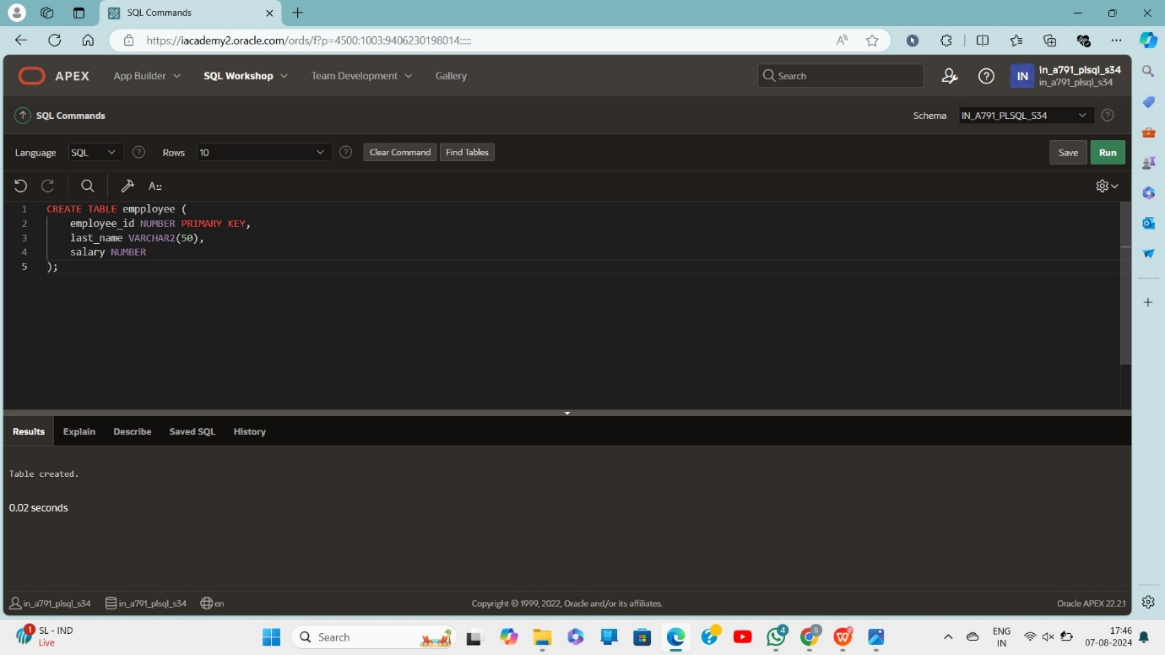

Insert values

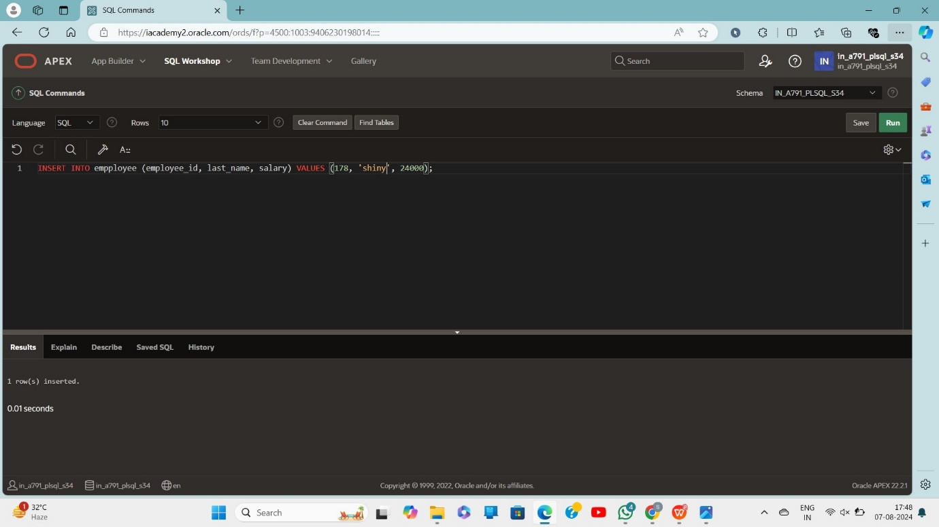

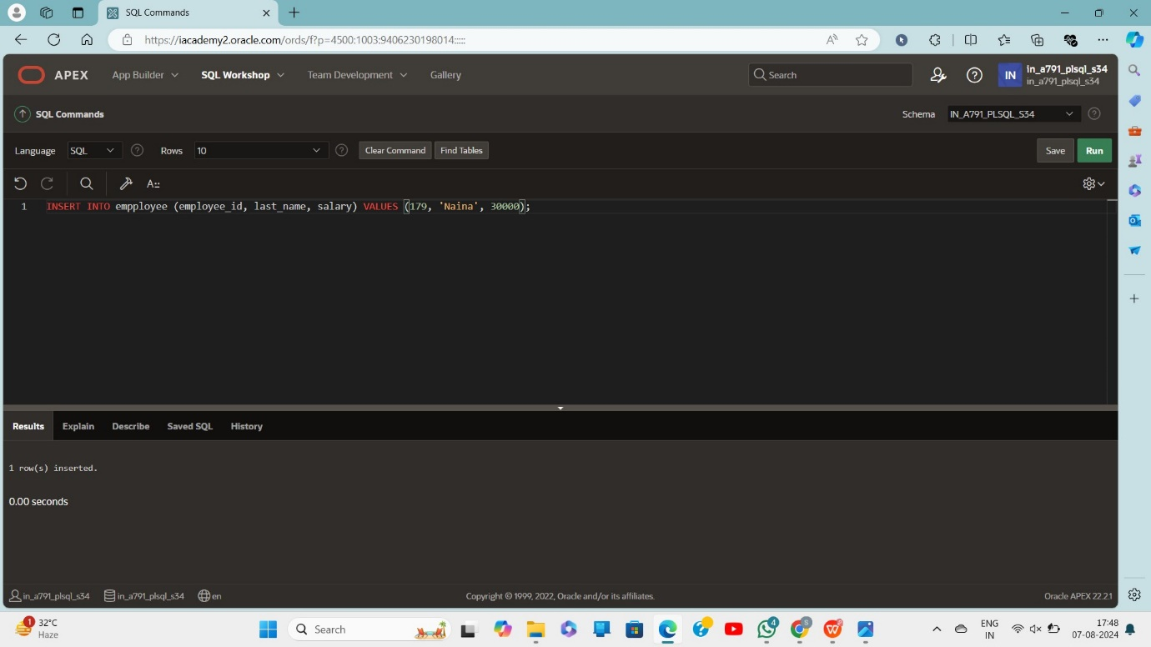

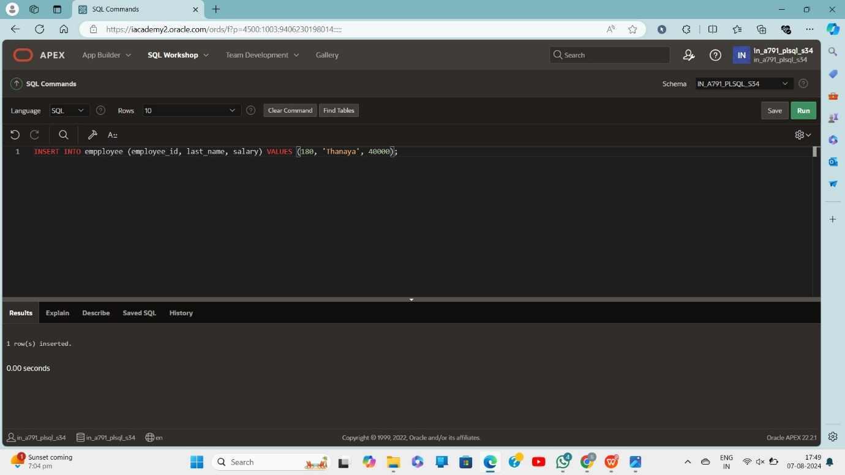

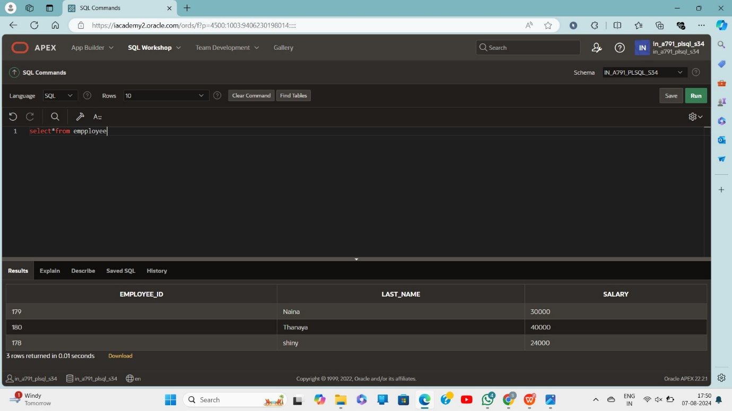

Create

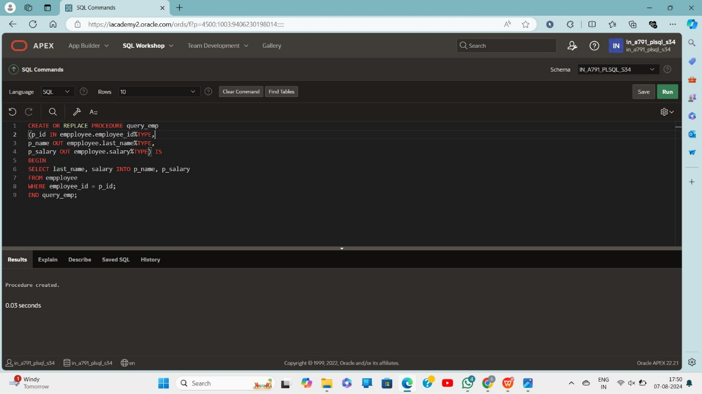

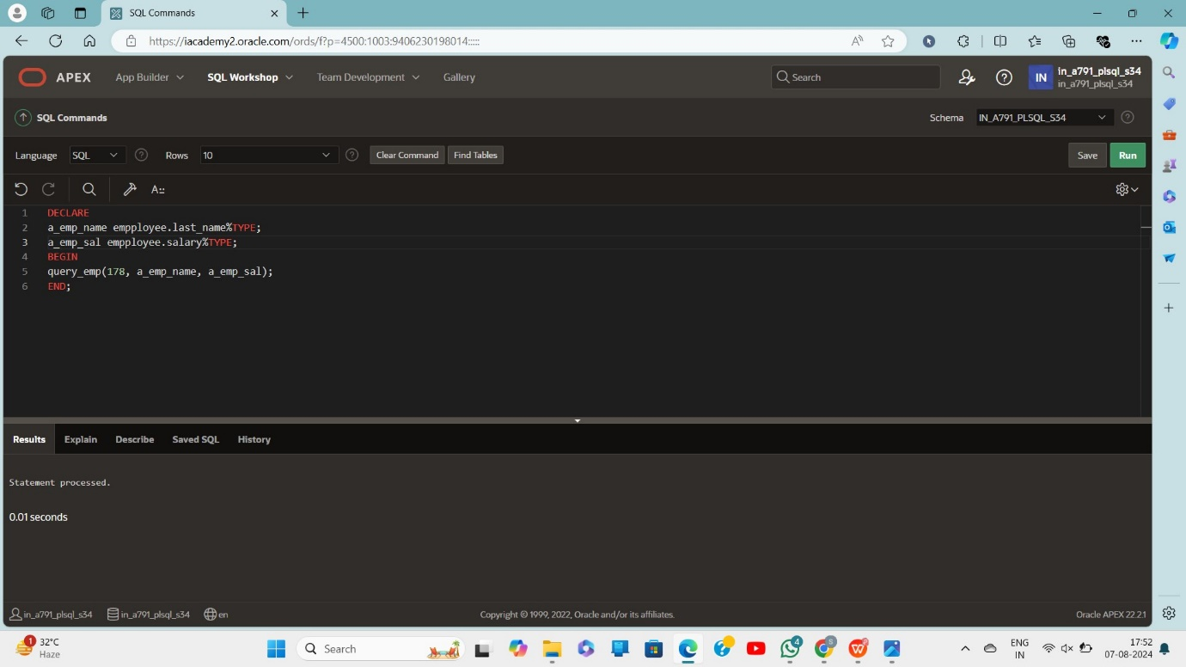

DECLARE

a_emp_name empployee.last_name%TYPE;

a_emp_sal empployee.salary%TYPE;

BEGIN

query_emp(178, a_emp_name, a_emp_sal);

DBMS_OUTPUT.PUT_LINE('Name: ' || a_emp_name);

DBMS_OUTPUT.PUT_LINE('Salary: ' || a_emp_sal);

END;

